**Final Project Report: The Smart Eraser**

ELEC_ENG 332: Intro to Computer Vision

Instructor: Prof. Ying Wu

By: Christopher Tsai

Partner: Nathaniel Nyberg

Evanston, IL

4 December 2020

**I. Personal Views and Interests**

As I write this statement, I find myself at the end of my life’s chapter here at Northwestern University, where for the past 4.25 years I have been pursuing joint BS and MS degrees in Mechanical Engineering. As I reflect upon my time here, I am deeply grateful for the amazing education that have I received, as well as for the many professional opportunities that Northwestern has provided. In particular, I am most thankful to the school for helping me develop and nurture my passion in robotics.

I took this course because I am deeply interested in how robot systems perceive the world and react to it. Computer vision is at the heart of robotic perception and is a rapidly evolving field that has kept its pace for many decades. Through this course, I have gotten a taste of fundamental computer vision topics such as connected-component labeling, histogram equalization, image segmentation, edge detection, Hough transform, face detection, motion tracking, camera calibration, image stitching, feature extraction, and image tagging. My favorite topics have been face detection and feature extraction. As a roboticist, I am deeply interested in additional topics such as 3D object recognition and structure from motion. If I stayed another quarter at Northwestern, I would take both ELEC_ENG 432 and ELEC_ENG 433.

**II. Project Description**

The project my partner and I chose is the “Smart Eraser”. The goal of the project is to implement a program that erases several handwritten characters on a newspaper page automatically and gradually in a given video, while keeping the background texture unchanged perceptively.

The handwritten characters spell “Can you erase me?” perpendicularly to the newspaper page and act as the foreground. The background is the newspaper page but is not detailed enough for the human eye to read the content of the newspaper.

Where does the “smart eraser” come to play? Well, in the video someone holds a pen whose tip moves along the handwritten words. The pen tip moves once from right to left in the duration of the video.

To visualize it better, below are some of the frames of the input video and of an example output that was given in the class assignment description.

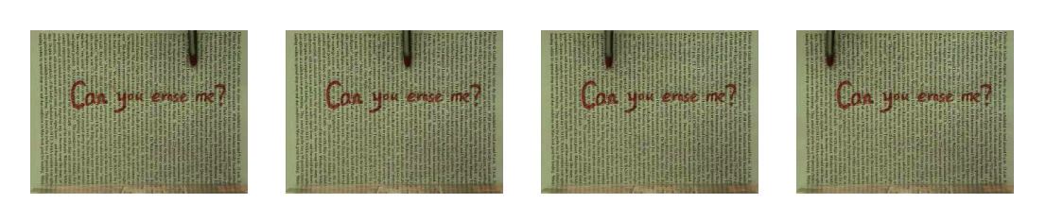

Figure 1: input image frames; (a) 100th frame, (b) 200th frame, (c) 300th frame, (d) 400th frame.

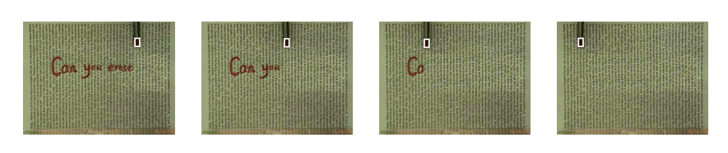

Figure 2: output image frames; (a) 100th frame, (b) 200th frame, (c) 300th frame, (d) 400th frame.

For example, Figure 1 (a) shows the 100th frame of the video, where the pen tip’s location is on top of the handwritten word “me”. In the corresponding output frame (Figure 2 (a)), the program uses the location of the pen’s tip as an indicator and erases the handwritten words between this location and the right end of the sentence. The class assignment description suggests the use of visual tracking techniques for identifying the location of the pen tip and texture impainting techniques for erasing the handwritten sentence, both previously covered in class.

**III. Our Design**

Our design consisted of three main parts: color segmentation (red detection), object tracking, and texture inpainting. The latter two techniques were the ones mentioned in the class assignment description.

The first part, red detection, is primarily used for segmenting out the handwriting of the video, which is in bright red font. By “segmenting out” we mean replacing the red pixels with black pixels (which have a value of 0 in most color schemes). This can be done once during the beginning of the whole process as the video exhibits no camera movement and the newspaper page remains still. The only thing that moves is the pen. See Algorithm 1 for pseudocode on this part of the algorithm.

Red detection starts by converting the first frame of the video from RGB to HSV format. This is done because unlike RGB, HSV separates luma, or the image intensity, from chroma, or the color information. This is very useful in this application as it takes out any possible noise from lighting change, focusing only on the pure color value.

Next, we initialize two HSV pixel values, which form the lower and upper limit of the range of red pixels we want to segment from the image. Each of these values is used as a threshold to create a mask of the image (containing pixels values that are higher than the lower threshold for one mask and lower than the higher threshold for the other). The two masks are then combined to select the pixels that fall in between the two thresholds.

Finally, since we are trying to remove pixels from the original image (turning them into zero-valued black pixels), we must invert the mask (so that the segmented pixels have a value of 0 instead of 255). Thus, by doing a bitwise AND with the original image we are able to replace the red pixels with black pixels.

Note that red detection uses a number of OpenCV functions to accomplish its tasks, namely cv2.cvtColor(), cv2.inRange(), cv2.morphologyEx(), cv2.bitwise_not(), and cv2.bitwise_and(). See Figure 3 for the resulting image of this step. Note that Figure 3 shows that the algorithm also segmented some red pixels from the pen tip as well as the bottom of the image. These pixels are considered noise and are easily ignored during the rest of the algorithm because their vertical pixel locations are near the top and bottom ends.

|  |
| --- |
| def findRed(img):      hsv = rgb2hsv(img)      lower_red = np.array([0,40,40])      upper_red = np.array([25,255,255])      mask = 1s where hsv is between lower red and upper red, 0s else      mask = bitwise_not(mask)      result = bitwise_and(img,mask)      return result |

Algorithm 1: red detection pseudocode.

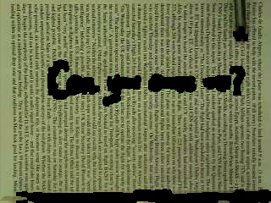

Figure 3: red detection results.

The next part of the algorithm is object tracking. Object tracking is used to track the location of the tip of the pen, which will let us know where to impose our “erasing” at each frame. This involves comparing the pixel values of the object’s location frame by frame using a cost function.

We first look at the pen tip’s location in the very first frame of the input video. We manually create a window of pixels containing the pen tip in order to tell the algorithm what it’s meant to track. This is called the template. The algorithm doesn’t conduct any fancy recognition on the pen, but instead simply finds out what group of pixels (of the same size as the template) looks the most similar to the template at each frame. It doesn’t search the entire image space but rather conducts a local search of user specified radius.

To compare each window to the template at each iteration, it uses a cost function. There are many cost functions to choose from, but we chose the sum of squared differences (SSD) metric for its simplicity. As the name suggests, this cost is calculated by summing the total differences of pixel values between each window and the template. Since our image processing code reads images as NumPy arrays, this was a very straightforward NumPy operation. See Algorithm 2 for the complete object tracking pseudocode and GIF 1 for the results for this step.

|  |
| --- |
| def objectTracking(I,row,col,T):        pos = [row,col]      subT = _getWindow(T,row,col,size)        for r,c from -RADIUS to RADIUS do:          subI = _getWindow(I,row+r,col+c,size)          temp_cost = sum(subT-subI)**2          if temp_cost < cost do:              cost = temp_cost              pos = [row+r,col+c]        return pos |

Algorithm 2: object tracking pseudocode.



GIF 1: object tracking results.

The third and final step of our algorithm is texture inpainting (or texture synthesis). This step utilizes the results of the two previous steps. It takes in the red pixel locations as well as the moving location of the pen tip and blends in the newspaper background into the red pixel locations as the pen tip moves through them.

The texture synthesis algorithm we used is the Efros-Leung algorithm. In a nutshell, this algorithm takes texture pixels that border black/unfilled pixels (we can think of these pixels as being “on the frontier”), finds a set of patches in the source texture image that most resemble the unfilled pixel's filled neighbors, and replaces the unfilled with one of these patches at random.

For our case, our algorithm first needs an example texture image of the newspaper background texture of the video. This image is what we are draw texture from in order to blend out the handwritten words.

At each frame of the video, we use the image output from red detection (an image that has black pixels where there were red) as well as the horizontal coordinate of the pen’s location from object tracking. You can imagine a vertical line crossing the image at this horizontal coordinate. We start by looking at the upmost black pixel of the handwritten character. We create a window of user-specified size around the black pixel. This window is considered the template in this step.

Next, we look in the example texture image for a window of the same size that has the highest similarity to the non-black pixels in our template. This is what the _findMatches() function does in Algorithm 3 below. For this subprocess, a mask containing the non-black pixels in the template is first created by thresholding up all non-black pixels. Next, this mask is multiplied by a gaussian kernel that gives higher weight to pixels closer to the “frontier” pixel. After that, this mask is overlayed on each pixel of the source texture image and a sum of squared differences comparison is conducted on each pixel of the texture image. Only the pixels that are within 20% of the minimum differences are considered potential matches. Finally, one of these stored pixels is selected at random in order to prevent repetitiveness.

The original black pixel is then replaced by this highest-similarity match. The location and value of this value is stored. The whole process is repeated for every black pixel in the vertical line and the updated image is outputted along with the saved pixel list at each frame. See Figure 4 for an example of how this texture synthesis looks like. The entire algorithm is summarized in Algorithm 4.

|  |
| --- |
| def synthesize(red,img,sample,col,size):        for pixel in column of red do:            if pixel is black do:              template = _getWindow(red,row,col,size)              matches = _findMatches(template,sample,size)              match = random pick of matches              img[row,col] = sample[match[0],match[1]]              red[row,col] = sample[match[0],match[1]]              record.append([row,col,sample[match[0],match[1]]])      return img,record  def _findMatches(T,I,size):        validMask = 1s where template is filled, 0s everywhere else      sigma = size/6.4      Gaussian = Gaussian2D(size,sigma)        totWeight = np.sum(kernel*validMask)      for i,j do:          for ii,jj do:              cost = sum(T[ii,jj] - I[i+ii][j+jj])**2              ssd[i][j] += cost*validMask[ii,jj]*kernel[ii,jj]        ssd /= totWeight      PixelList = all pixels (i,j) where ssd[i,j] <= min(ssd)*(1+ErrTresh)        return(PixelList) |

Algorithm 3: texture synthesis pseudocode.

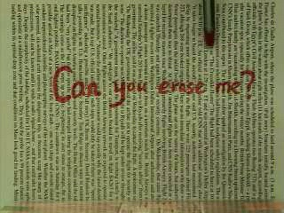 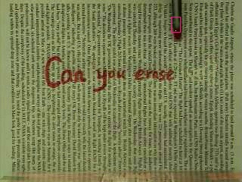

Figure 4: texture synthesis results; (a) before, (b) after.

­­­­­­­­

|  |
| --- |
| def main():    Read all the separate frames from the input video  Use the findRed() function to detect the red pixels  Isolate a portion of the first frame with no red pixels to use as a sample image  Start image tracking by manually finding and recording position of pen  Iterate through frames and do the following:  Run objectTracking() to update position of pen  Replace pixels in new frame that were updated in previous frames  Inpaint holes at pen location using texture via synthesize() function  Save changed pixels to update with new frame    Save processed image to output list  Create output video from output list |

Algorithm 4: full algorithm pseudocode.

**IV. Results and Analysis**

GIF 2 below shows the overall results of our algorithm. Clearly, our algorithm is able to effectively accomplish its goal of “erasing” the red text as the pen tip moves along it by using the aforementioned techniques of color segmentation (red detection), object tracking, and texture impainting.



GIF 2: final results.

Each step of the process contributed well to the end result. The red detection step effectively segmented out the red pixels of the handwriting. As previously mentioned, it also segmented some pixels of the pen tip (as the pen tip would obviously also be red as it produced red ink) as well as some red-ish pixels near the bottom of the video (it is unclear what those pixels portray). However, our algorithm was easily able to ignore these pixels by choosing to constrain the boundary to pixels near the handwriting. The object tracking step worked perfectly, and we faced minimal challenges while implementing it (mostly due to the fact that one of our previous assignments dealt with object tracking). Finally, the texture impainting step was successful in seamlessly blending in the handwritten characters into the newspaper background as the pen tip crossed them.

Texture synthesis was definitely the “meat” of this project, and thus the most challenging step. We are very satisfied with the results of our output video but could not help but notice a few very minor imperfections that a normal viewer would not catch. Figure 5 shows a frame of the final scene of the output video, with the newspaper texture fully blended in. If looking closely, one can notice that the synthesized texture does appear to be slightly lighter than the original texture. Moreover, there are a couple of small “blobs” (for example, a little to the right of the image center) where pixels seem to be mashed together, producing a monochromatic texture with no distinguishable newspaper words. Again, these are very minor details that did not prevent us from achieving our project goals.

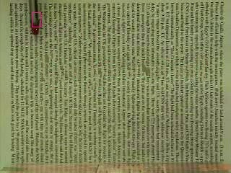

Figure 5: final texture synthesis frame.

One final point to note is that our algorithm could’ve most likely been completed without the red detection step (but rather using just the two recommended techniques of object tracking and texture impainting). However, the red detection step was beneficial in aiding the texture synthesis step produce more realistic textures. This is because the texture synthesis algorithm only had to focus on the individual red-segmented pixels rather than a vaguer rectangular area, increasing accuracy. Without this additional degree of freedom, the algorithm would’ve had to impaint more pixels than necessary, increasing computation time.

**V. Future Work**

As stated before, there is still some room for improvement regarding the texture impainting step of the algorithm. There are a few additional methods that can be implemented in a future edition of this project.

The first method can be added on to our algorithm as a post-processing step. This step would involve blurring the slight contour difference between the impainted pixels and the original pixels. Like this, the light difference between both can be reduced. Another method that can be used in conjunction could be to simply increase the brightness of the impainted pixels slightly to match the background. Finally, in order to account for the small “blobs” of monochromatic texture in our result we could experiment with the hyperparameters of our algorithm, namely kernel and window sizes. We could also experiment with other texture synthesis methods that were covered in class, such as dynamic programming.

A final improvement to note is computation time. Our full algorithm takes about 15 minutes to run due to the multiple nested loops that need to be traversed. One possible solution for decreasing computation time running the code using our computer’s GPU rather than CPU, through a library such as CuPy (which manipulates Numpy arrays on Nvidia GPUs by leveraging the CUDA GPU library).

**VI. Course Feedback and Suggestions**

As someone deeply interested in robotic perception, taking this course was a must for me. I am generally very satisfied with what I learned from it, especially from all the assignments and final project.

Even though the weekly assignments during the first half of the course were a decently heavy workload, they allowed me to experience hands-on what was taught in class. I wish this pace was continued for some of the later assignments, especially for face detection and feature extraction (two topics I’m very interested in). Without a hands-on assignment, learning is not the same.

That said, an assignment every week for the entire quarter might be too fast paced for many students (including myself). A different model could be combining two topics and assigning homeworks every two weeks, to allow students more flexibility and accounting for students’ differing commitments week by week.

Lastly, this quarter I struggled to grasp some concepts in lecture due to the pressure of writing all the concepts down, which stemmed from the lack of video recordings of the class. If classes were recorded, I could absorb lecture material without the distraction of writing things down as I could re-watch lectures later if needed. This has worked marvelously for my other classes as I am able to grasp general-picture ideas in lecture and go back to their recordings for specific details (such as equations). I believe most of my classmates would agree with me as many expressed concerns regarding the lack of recording in our group chats.

Regardless, I thoroughly enjoyed this class and believe it to be an essential offering at Northwestern. I with the instructor and TA’s the best in their future endeavors.